**PRATIK MATKAR**

**CA2020 BOOTCAMP - ASSIGNMENT DAY-1**

**Question 1: What is Cache Memory?**

**Ans**: We can define cache memory as a high-speed memory which is used to speed up and synchronize with a high-speed CPU. Cache memory is a temporary storage memory in which the computer’s processor can retrieve the data easily.

[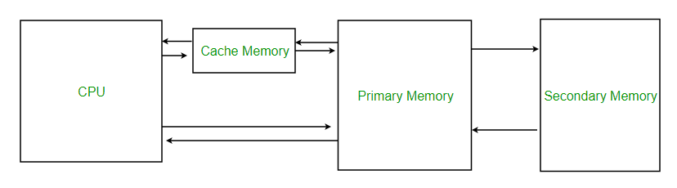](https://www.geeksforgeeks.org/cache-memory-in-computer-organization/)

Cache memory is sometimes called CPU memory because it is typically integrated directly into the CPU chip or placed on a separate chip that has a separate bus interconnect with the CPU.

Size of cache memory is much smaller than the primary memory. It is around 100 times faster than RAM, therefore it responds quickly to the CPU requests.

There are three levels in cache memory:

1. L1: It is also known as a primary cache. It is very fast and small and it is embedded in the processor chip and is known as CPU cache.
2. L2: It is also known as a secondary cache. It has more capacity than the primary cache or L1. It can be either embedded in the CPU or it can be in the form of a separate chip and have a high-speed alternative system bus connecting the cache and the CPU.
3. L3: This cache is a specialized memory and is basically used to improve the performance of L1 and L2. L3 doubles the speed of DRAM.

**Question 2: What is Disk Management?**

**Ans:** Disk Management allows us to perform advanced storage tasks. Basically, it is used to manage all the drives which are installed on the computer. Some of these are hard disk, flash drives and optical disk drives.

Disk Manager can also be used for partitioning drives and formatting the drives. Disk Manager can also be used to check free hard drive space. In disk management, we can create and attach virtual hard disk files. If you want to open the disk management go to the computer utility in your operating system and open disk manager from there.

**Question 3: Cache vs RAM**

|  |  |
| --- | --- |
| **Cache** | **RAM** |
| It is faster. | It is slower than cache. |
| It is located closest to the CPU. | RAM memory is located near the cache memory. |
| It is costlier. | It is cheaper than cache. |
| SRAM is used for cache. | DRAM is used as a RAM. |
| Usually measured in KB or MB. | Usually measured in GB. |

**Question 4: HDD vs SSD?**

|  |  |
| --- | --- |
| **HDD** | **SSD** |
| HDD refers to Hard Disk Drive. | SSD refers to Solid State Drive. |
| Uses mechanical platters and a moving read/write head to access data | It stores data on instantly-accessible memory chips. |
| It is slower than the SSD. | It is faster. |
| It is cheaper. | Its is costlier than HDD. |
| It requires more power to operate. | It requires less, therefore, it gives better battery life. |
| Data transfer rate is 30-150 MB/s | Data transfer rate is 500 MB/s. |
| It has spinning disks inside where data is stored magnetically. | All data is stored in integrated circuits. |
| SSDs for computers are available in 120 GB to 4 TB capacities. | HDDs can go anywhere from 250 GB to 14 TB. |